# Jingmai Tea Mountain

Jingmai Tea Mountain is located in the southwest of Yunnan, the forests here are dense, the mountains here are beautiful, and hundreds of natural villages are nestled against the mountains, like a fairyland away from the hustle and bustle. Jingmai Tea Mountain is famous for its tea culture and is known as the "Hometown of Pu'er Tea"..…

(一个视频，景迈山概览）

* One on one personalized course
* Immersive experiences of scenery, culture and local life
* Excellent tutors with professional certificates and rich teaching experience
* 3 meals Monday to Friday and accommodation

**One on one personalized course**

Course type available：

🗹 one on one intensive course for all language level/goals and culture demand

🗹 one on one Travel Chinese

🗹 one on one HSK preparation

We will **tailor your course** to your personal demand and language level, match you with the tutor who is most suitable for you as well.

Classes are held from every Monday to Friday. You can choose to study **4 hours, 5 hours or 6 hours** per day. The daily class schedule is very **flexible** and can be adjusted according to your dynamic requirements.

Your tutor will not only help you achieve your learning goals, but also create rich **real-world** contexts for you and accompany you to **practice** in all-Chinese speaking environment, truly **combining learning with application** and naturally **integrating into the local life**.

**Immersive experiences of scenery, culture and local life**

See how nature turns mountains, clouds and trees into paintings

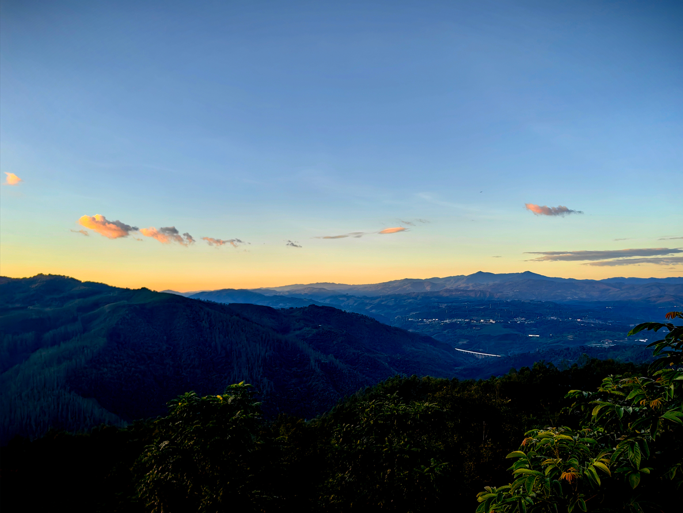

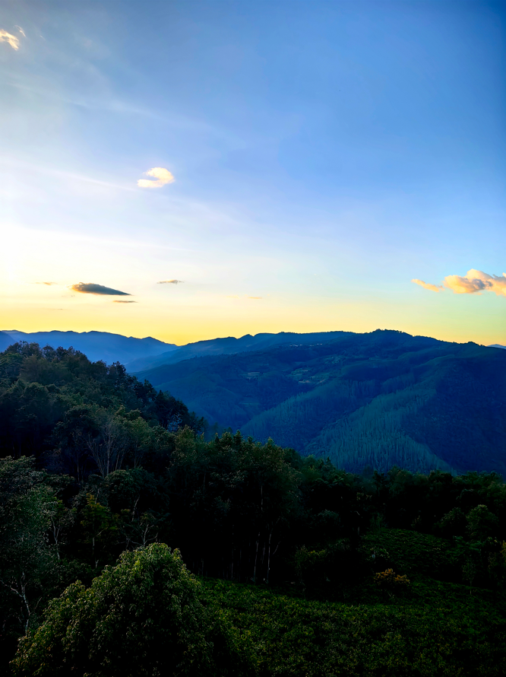 

Feel the charm of the thousand-year-old trees

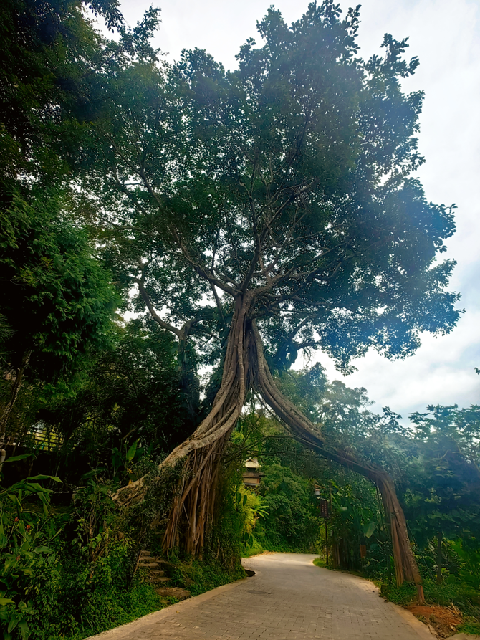 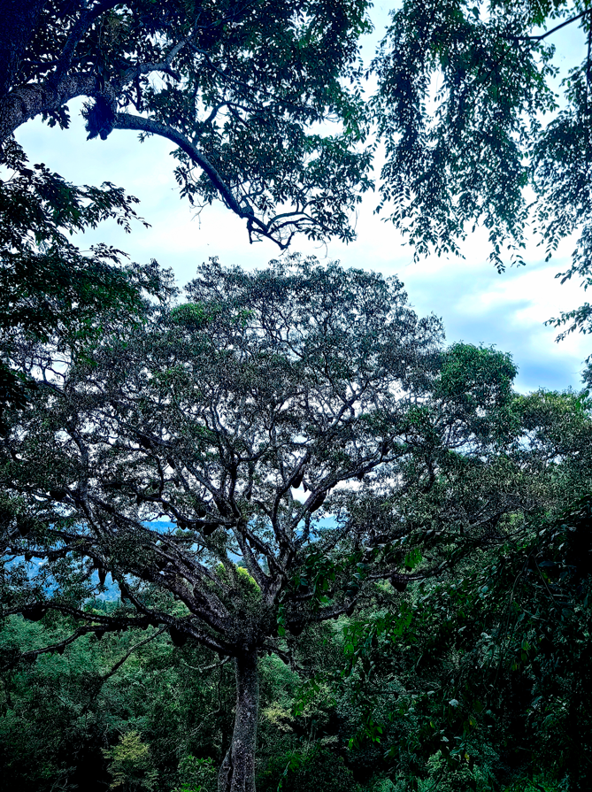

Pick fresh tea leaves with the local people in the mountains and experience the entire tea-making process.

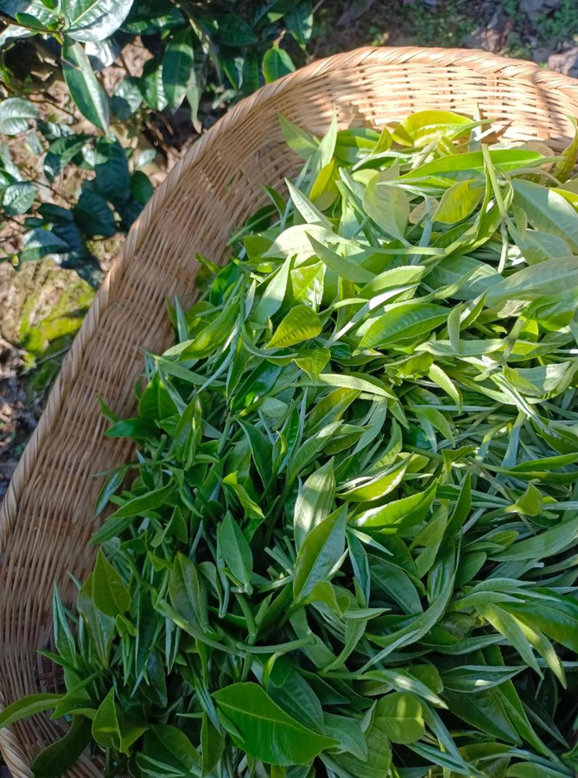 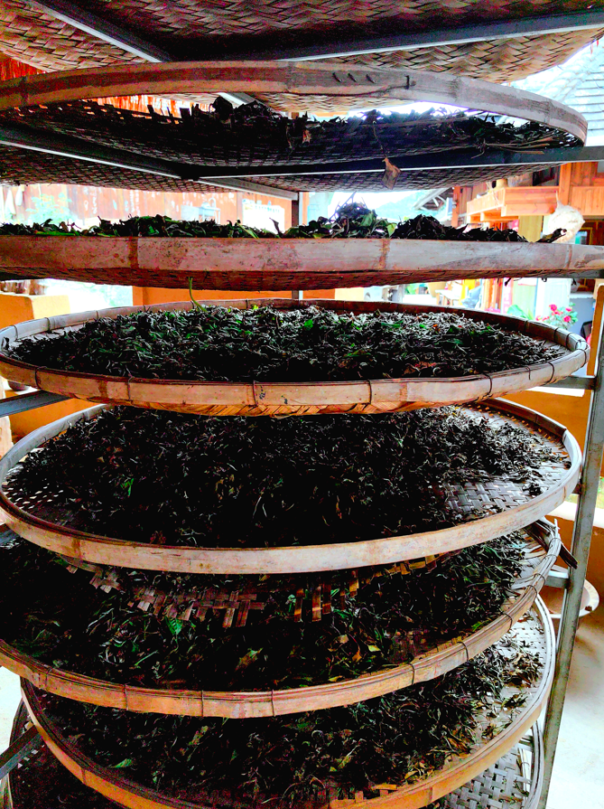

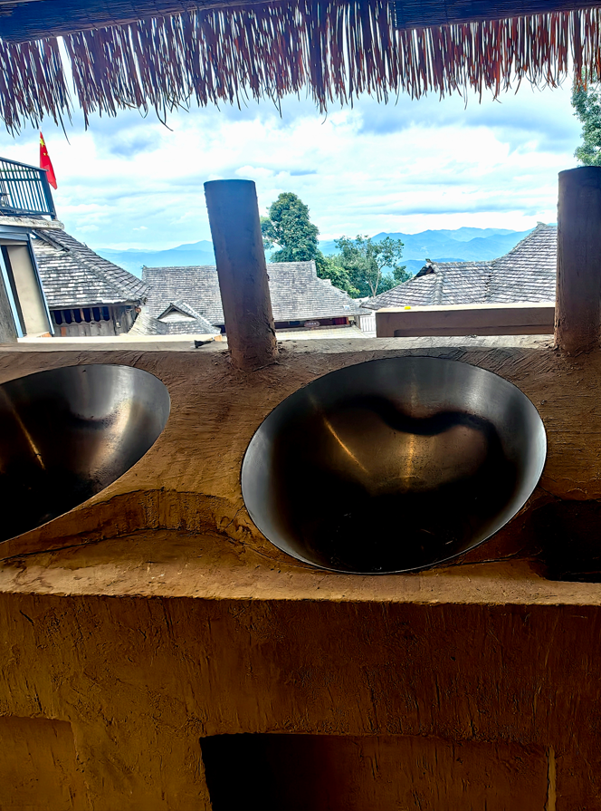 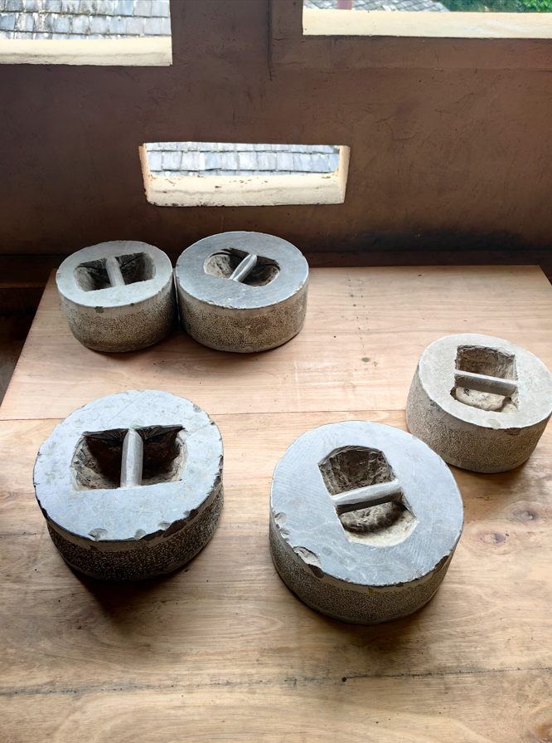

Take a walk in the ethnic minority villages and see the unique traditional architecture

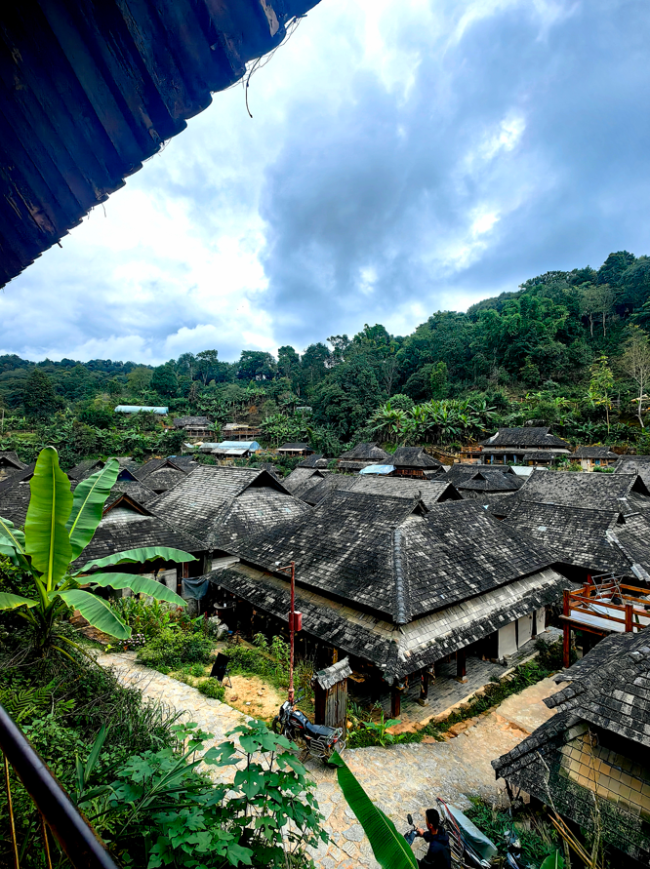 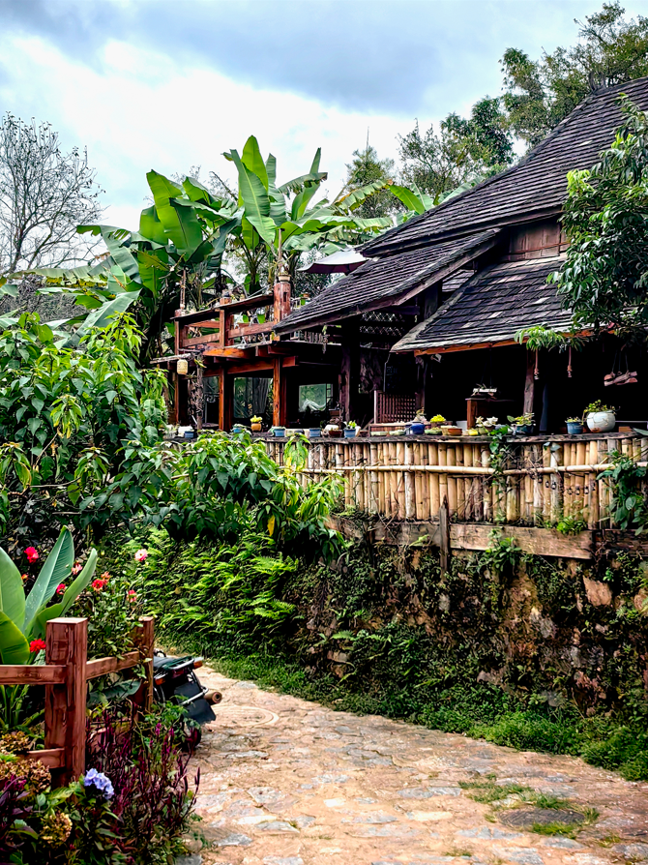

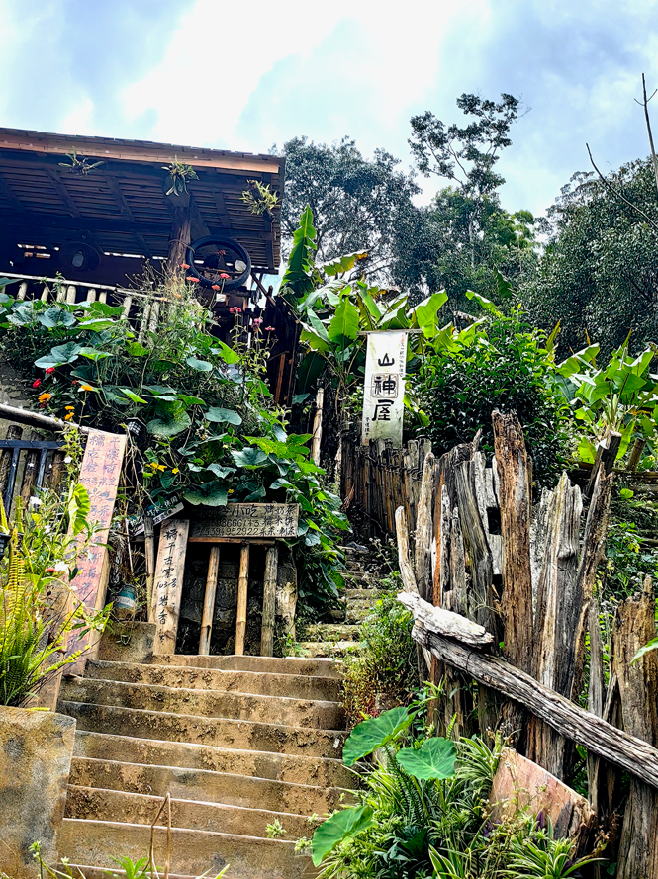 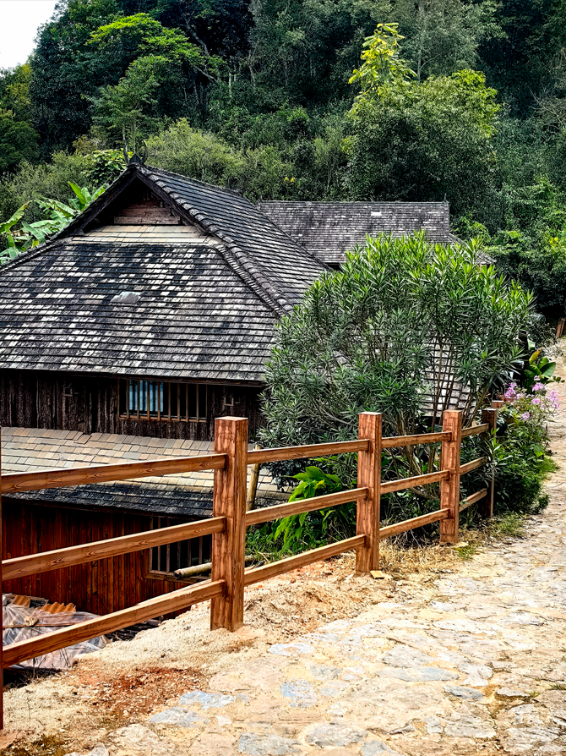

Immerse yourself in the lives of local people and the culture of the Bulang/Dai people

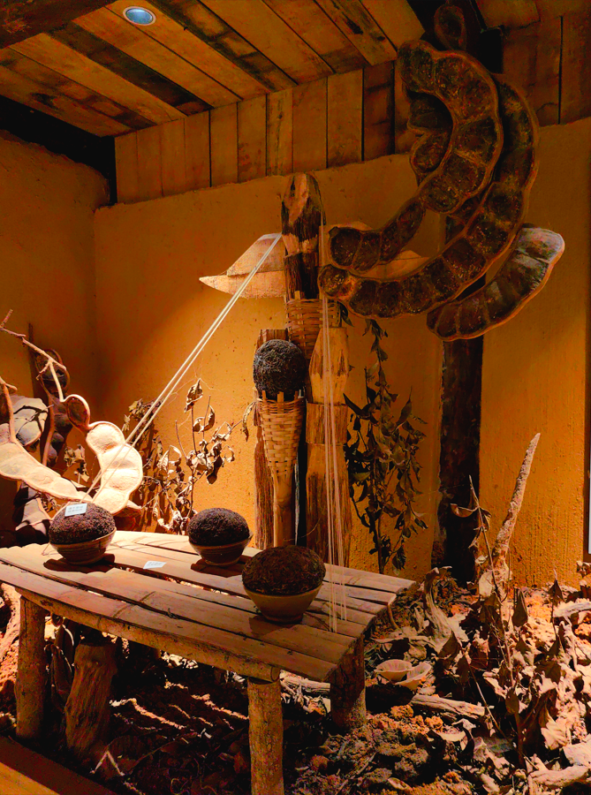 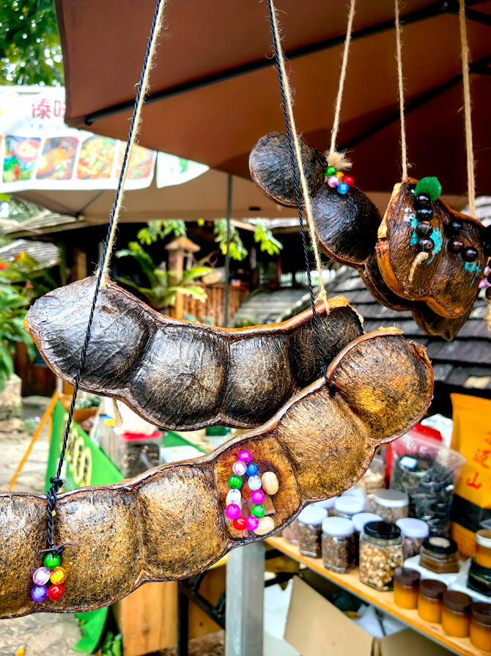

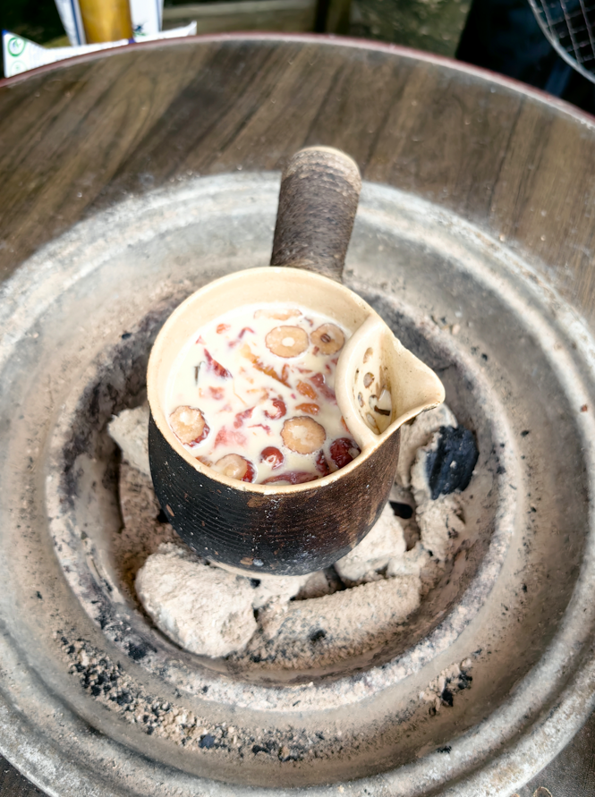 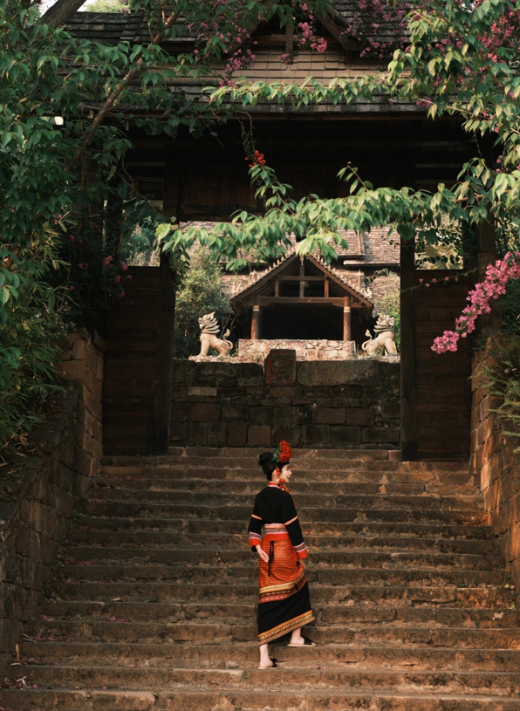

**Excellent tutors**

All tutors in our team have undergone comprehensive **training** and hold **professional** certificates，CTCSOL（Certificates for Teachers of Chinese to Speaker of Other Languages）or Teacher qualification certificate，together with **rich teaching experiences.**

They will provide you with patient, professional and targeted teaching, and solve your problems with a variety of different methods, making the lessons **interesting and practical.**

**（老师和学生一对一上课图片）**

**（这里请增加一个按键链接到导师团队）**

**More info about tutors team**

**Accommodation**

The accommodation for you is just **among the local village.**

Your room is an independent room with a private bathroom, clean, tidy, **safe** and comfortable.

Free room cleaning service is offered **everyday**.

24-hour hot water, WIFI and other necessary living facilities are included.

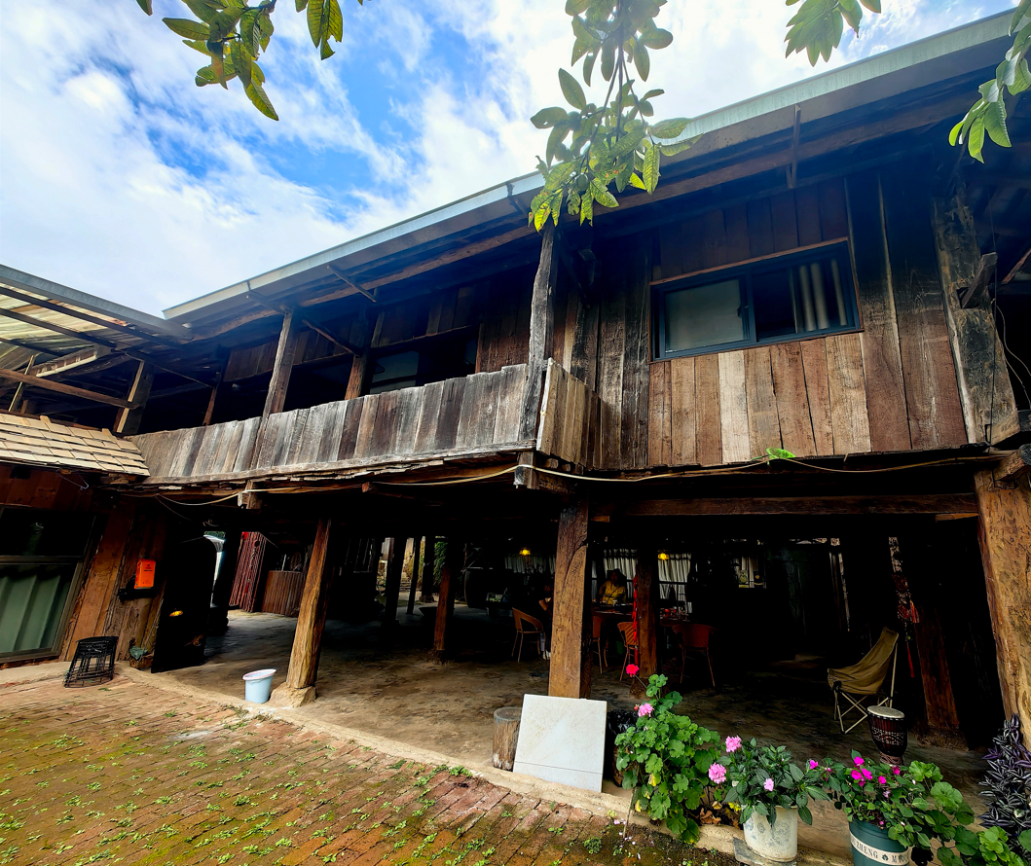 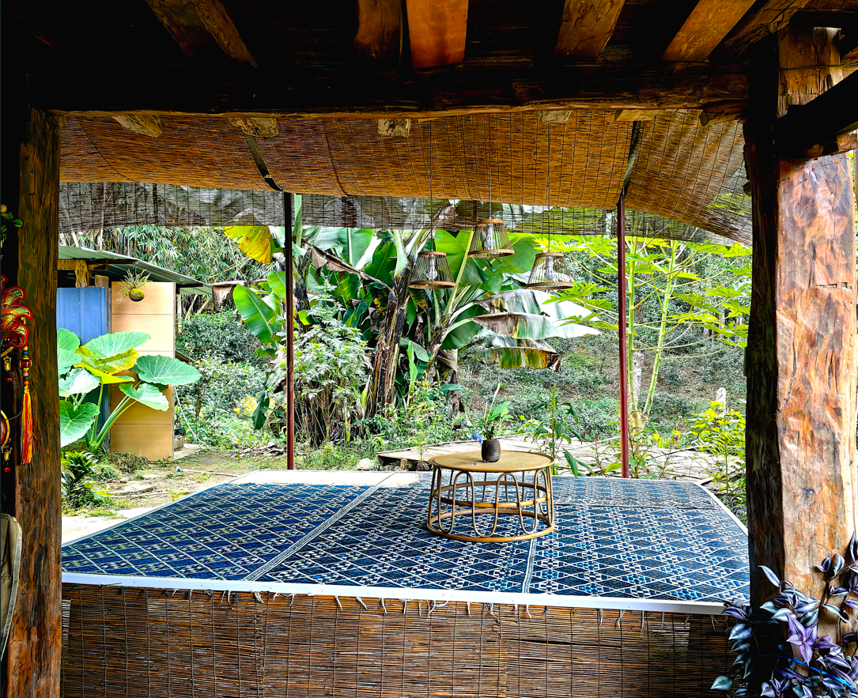

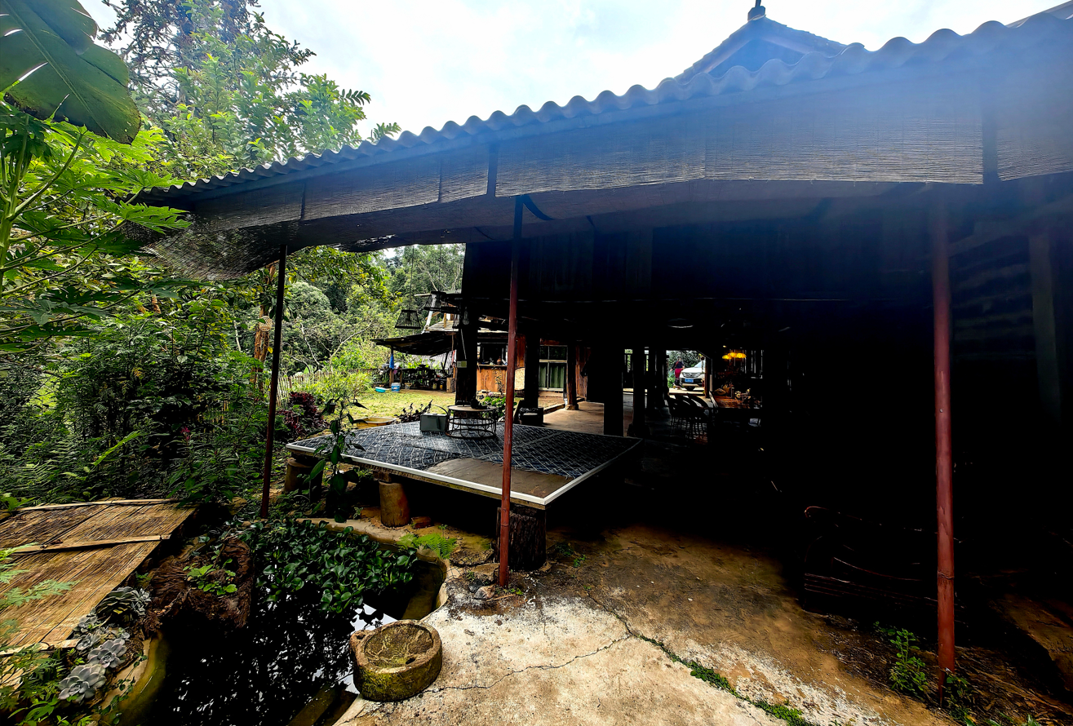 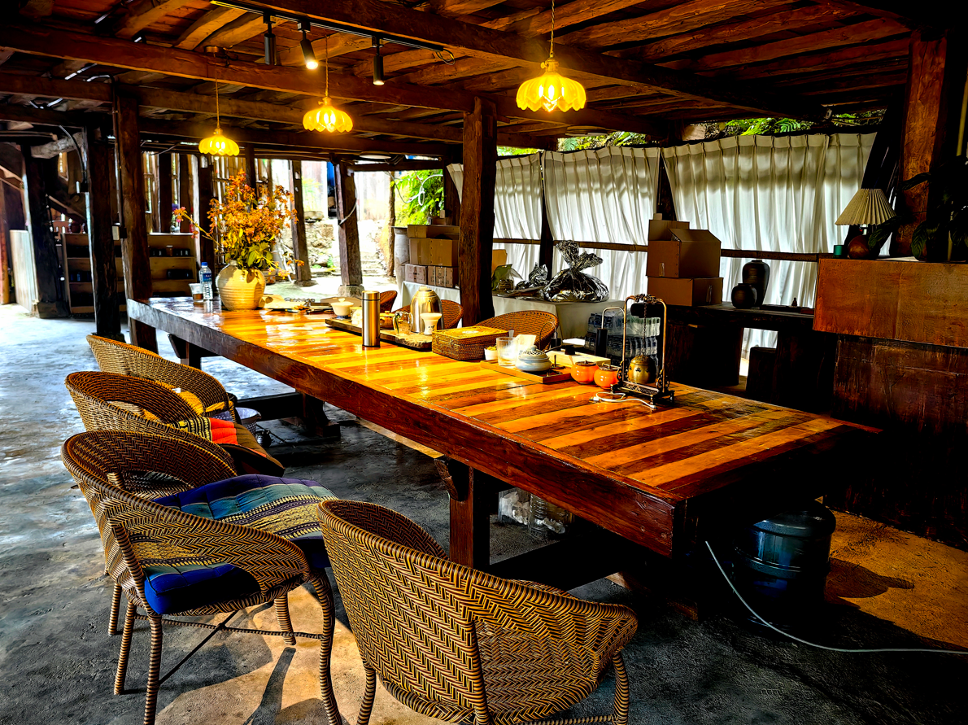

**How to get Jingmai tea Moutain**

Jingmai Tea Mountain is located in the southwest of Yunnan, Langcang County, Pu'er City. You can get provincial capital Kunming by plane first and then take the high-speed rail to Puer city, we will pick you up there to beautiful Jingmai Tea Moutain for free.

 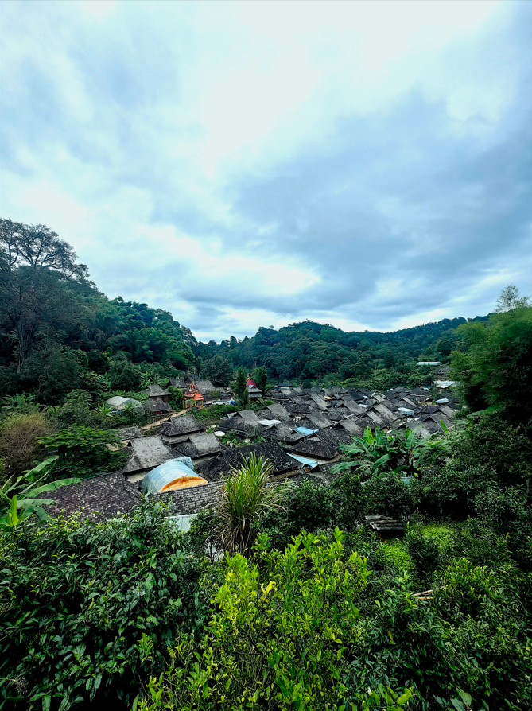

**Pricing**

**Special offer！**

4 hours per day (20 hours a week)

$1740/ week

5 hours per day (25 hours a week)

$1920 / week

6 hours per day (30 hours a week)

$2050/ week

**Ready to launch your Chinese learning journey?**

**Apply now**

The fee includes:

🗹 Personalized Chinese classes per week

🗹 Program certificate

🗹 3 meals Monday to Friday and accommodation

🗹 Kunming airport pick-up and drop-off

🗹 Pick-up and drop-off for Puer city to Jingmai Tea Moutain

🗹 Orientation

🗹 All the campus facilities

🗹 Room cleaning everyday

🗹 Free WIFI

🗹 Commonly used medicines

🗹 24/7 support

🗹 Visa support materials